

**School of Computer Science and Engineering**

**(WINTER 2022-2023)**

Student Name: **Rachita Batra**

Reg No: **22MCB0023**

Email:[rachita.batra2022@vitstudent.ac.in](mailto:rachita.batra2022@vitstudent.ac.in)

Faculty Name: **DURGESH KUMAR**

Subject Name with code: SOCIAL NETWORK ANALYticS Lab – MCSE618P

Assessment Report

*Date of Submission: 23/03/2023*

**Table Of Content**

|  |  |  |
| --- | --- | --- |
| CONTENT |  | PAGE NO. |
| Graphs | Types Of Graphs | 3 |
| Libraries | Numpy, Pandas etc. | 3 |
| Part A | Creation of directed and undirect graphs | 4 |
| Part B | For Undirected Graph - Finding no. of nodes, edges, node with maximum degree, nodes with minimum degree.  For Directed Graph - Finding no. of nodes, edges, node with maximum indegree, nodes with minimum indegree, node with maximum outdegree, nodes with minimum outdegree. | 6 |
| Part C | Adjacency Matrix  Finding adjacency matrix for directed graph (weighted and non-weighted) graph, Un- directed graph (weighted and non-weighted) graph. | 8 |
| Part D | Centrality Measures and its types  Calculation of various centrality measures for both directed and un-directed graphs.  Analysing nodes with highest centrality score for all centrality measures (directed and un-directed graph). | 9 |

**GRAPHS**

A graph is a visual representation of the connections between individuals or entities in a social network. A graph consists of nodes (also known as vertices) and edges (also known as ties or links).

Nodes represent the individuals or entities in the social network, and edges represent the relationships or interactions between them.

For example, in a social network of Facebook users, nodes could represent individual users, and edges could represent friend connections between them.

**Types of Graphs: -**

**Directed Graph –** In a directed graph, edges have a specific direction, indicating that the relationship or interaction between two nodes is asymmetric.

**Undirected Graph –** In an undirected graph, edges have no direction, indicating that the relationship or interaction between two nodes is symmetric.

**Weighted Graph –** In a weighted graph, each edge has a numerical value, indicating the strength or intensity of the relationship or interaction between two nodes.

**Unweighted Graph -** In an unweighted graph, all edges are considered to have equal importance.

**LIBRARIES USED**

1. **NumPy:** NumPy is a Python library used for numerical computing. It provides support for multi-dimensional arrays and matrices, along with a large collection of mathematical functions to operate on these arrays. It's used in a wide range of scientific and engineering applications, such as data analysis, image processing, machine learning, and more.
2. **Matplotlib:** Matplotlib is a plotting library for Python that provides a wide range of 2D and 3D visualizations. It enables users to create a variety of plots, including line plots, scatter plots, bar plots, histograms, and more. It's widely used in data visualization and scientific research, as well as in teaching and learning.
3. **Pandas:** Pandas is a library for data manipulation and analysis in Python. It provides data structures for efficiently storing and manipulating large datasets, as well as a wide range of functions for working with data. Pandas is often used in data science, finance, and other fields where large datasets need to be analysed and processed.
4. **NetworkX:** NetworkX is a Python library for the creation, manipulation, and analysis of complex networks. It provides tools for creating networks, visualizing them, and analysing their properties. NetworkX is often used in social network analysis, biological network analysis, and other fields where network analysis is required.

Importing the necessary libraries

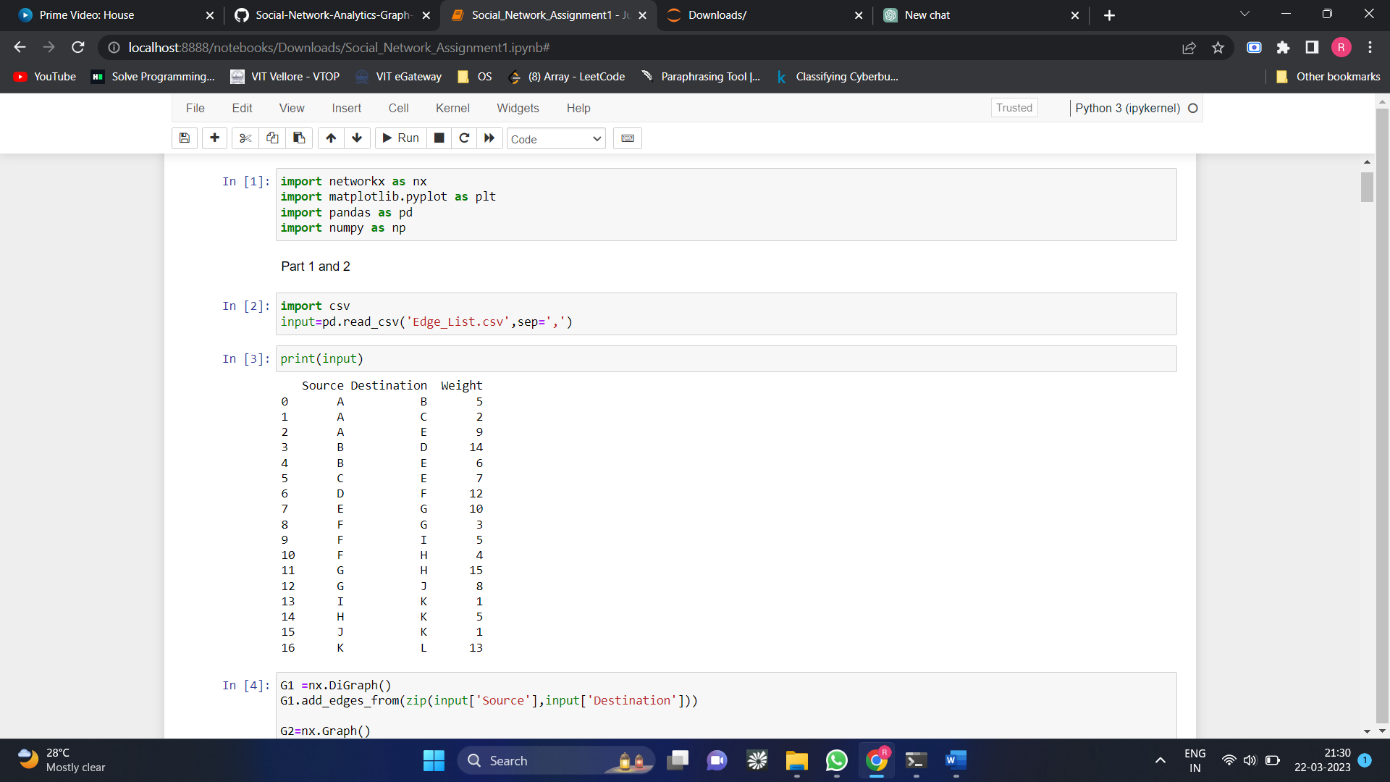

Reading the csv file



Description Of csv file



*PART-A*

* Creating an empty directed graph and adding edges

To generate a directed graph using NetworkX, you can use the ***DiGraph()*** method.

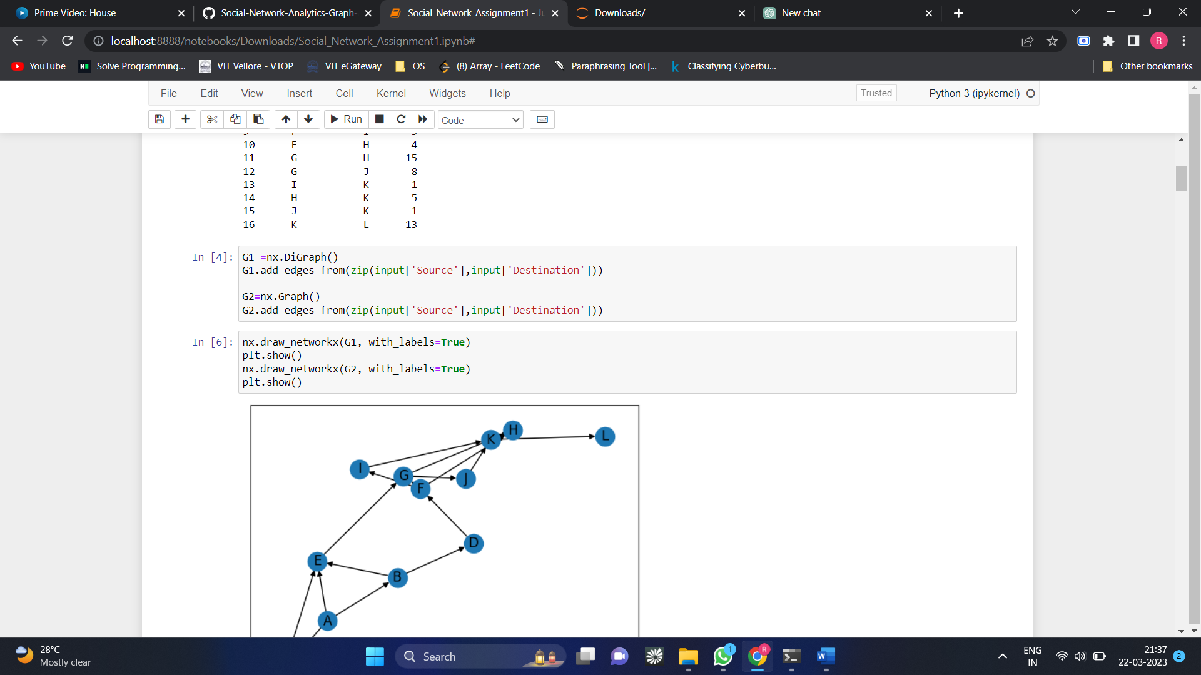

* Plotting a Directed Graph without weights

**

*Explanation of above code: This code generates a directed graph plot using the NetworkX and Matplotlib libraries in Python. The nodes of the graph are drawn using the draw_networkx_nodes function of the NetworkX library. The edges of the graph are drawn using the draw_networkx_edges function of the NetworkX library. The labels for the nodes of the graph are drawn using the draw_networkx_labels function. The plot is displayed using the show function of the Matplotlib library.*

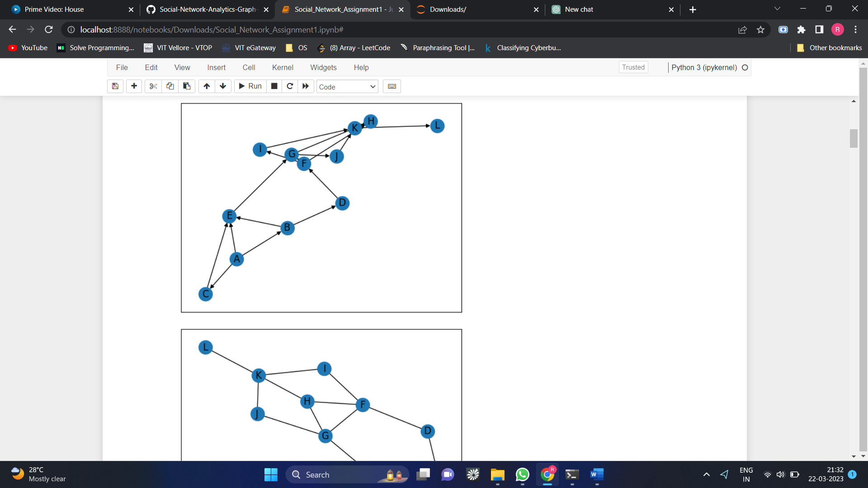

* Creating a directed graph and adding edges with weights
* Plotting a Directed Graph with weights

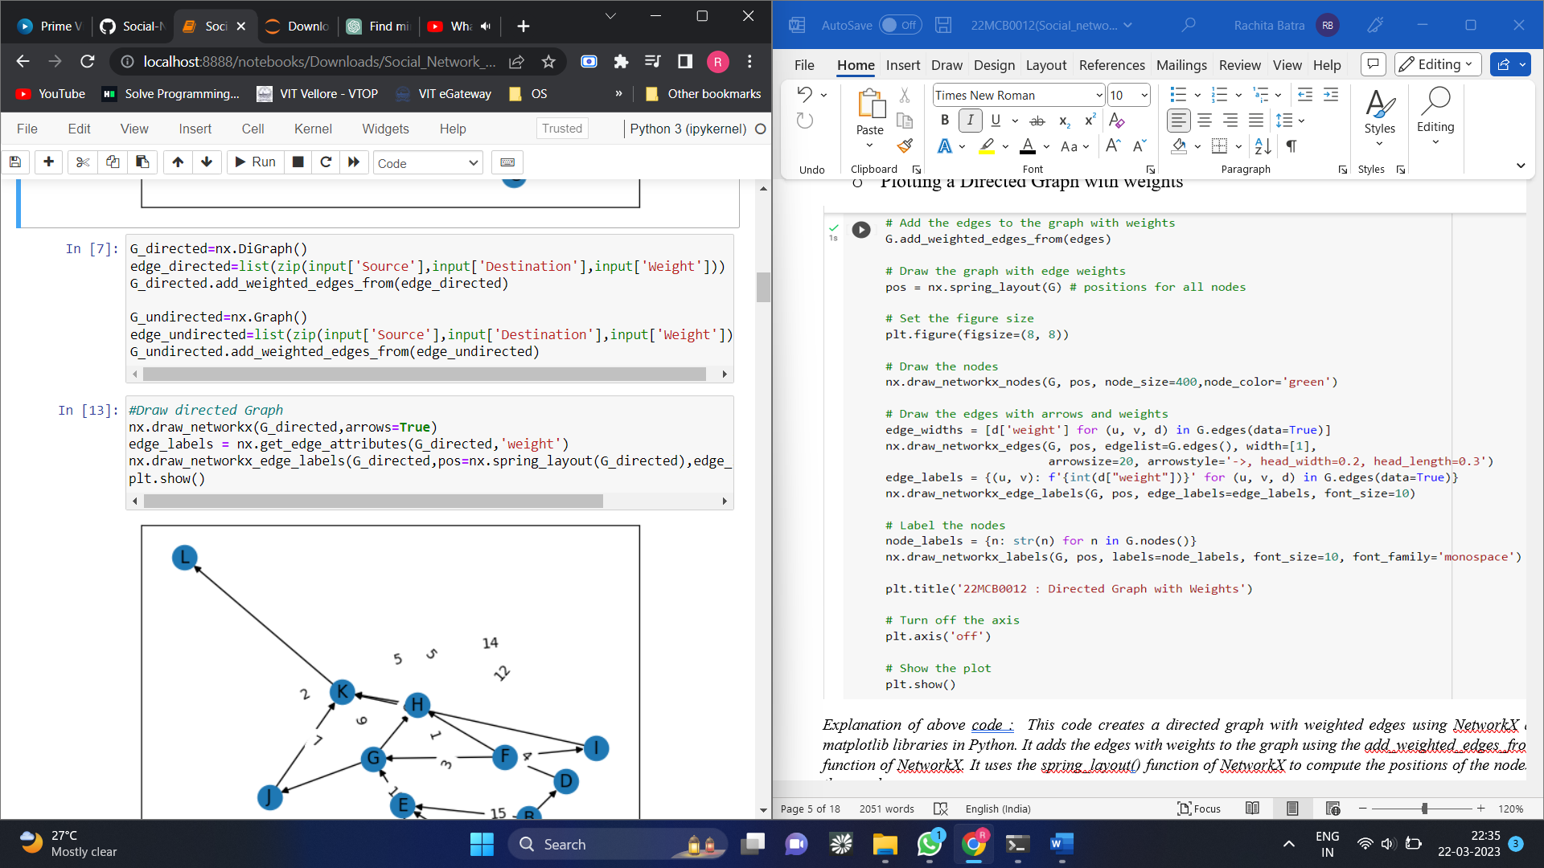



*Explanation of above code : This code creates a directed graph with weighted edges using NetworkX and matplotlib libraries in Python. It adds the edges with weights to the graph using the add_weighted_edges_from() function of NetworkX. It uses the spring_layout() function of NetworkX to compute the positions of the nodes in the graph.*

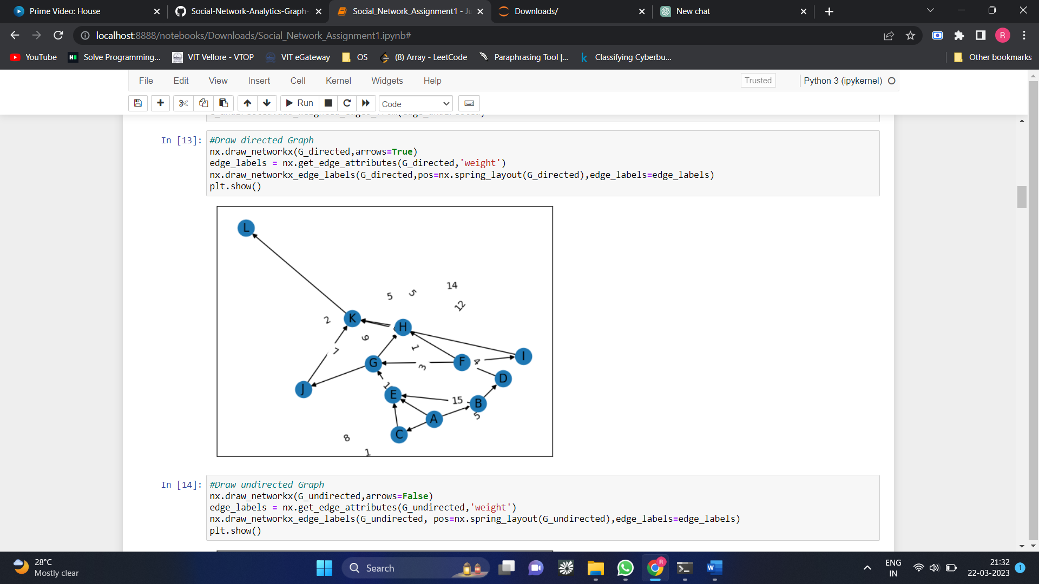

* Creating an empty Un-directed graph and adding edges without weight

An empty undirected graph is created using ***nx.Graph()****.*

* Plotting a Un- Directed Graph without weights

**

**

*Explanation Of above code : The graph is then drawn using nx.draw_networkx_nodes(), nx.draw_networkx_edges(), and nx.draw_networkx_labels().*

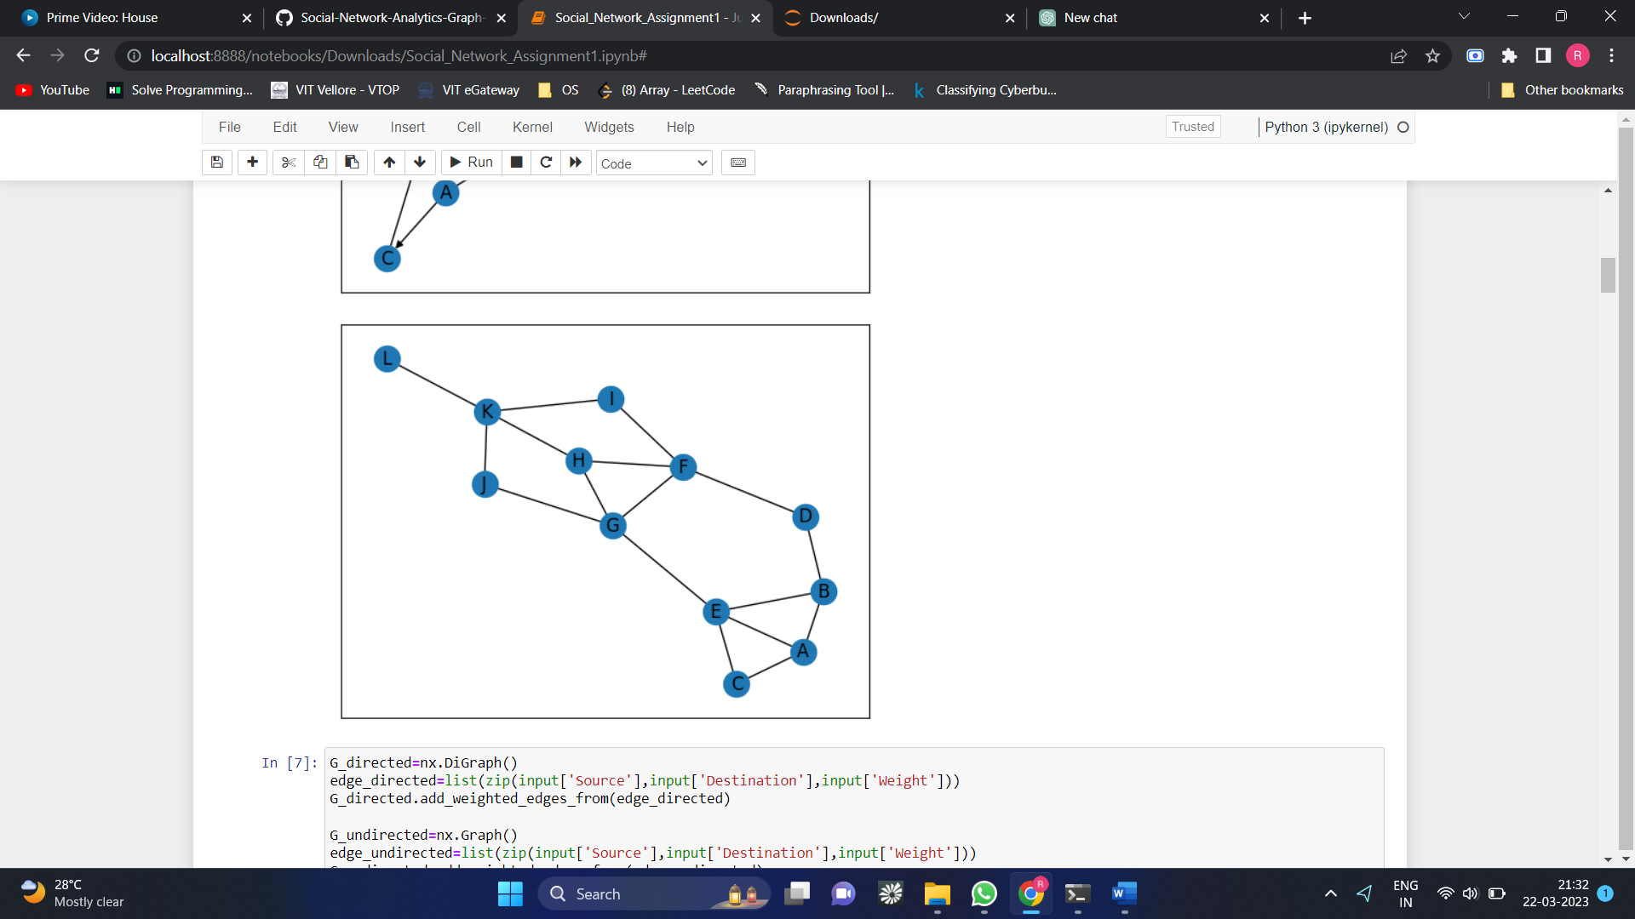

* Creating an Un-directed graph and adding edges with weights

The edges are then added to the graph using **G.add_weighted_edges_from(edges).**

* Plotting a Directed Graph with weights



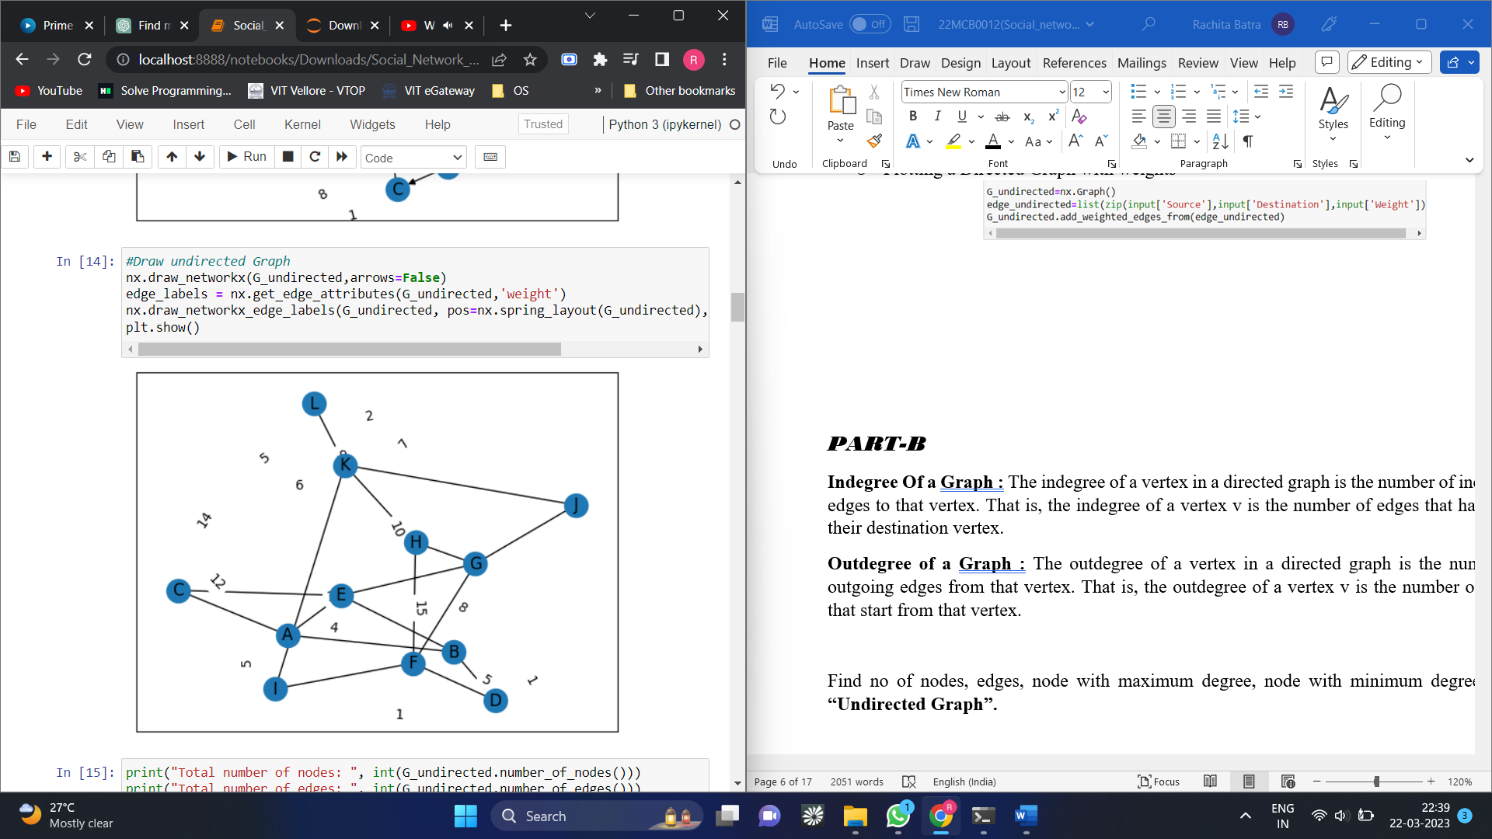

*PART-B*

**Indegree Of a Graph:** The indegree of a vertex in a directed graph is the number of incoming edges to that vertex. That is, the indegree of a vertex v is the number of edges that have v as their destination vertex.

**Outdegree of a Graph :** The outdegree of a vertex in a directed graph is the number of outgoing edges from that vertex. That is, the outdegree of a vertex v is the number of edges that start from that vertex.

Find no of nodes, edges, node with maximum degree, node with minimum degree in an **“Undirected Graph”.**

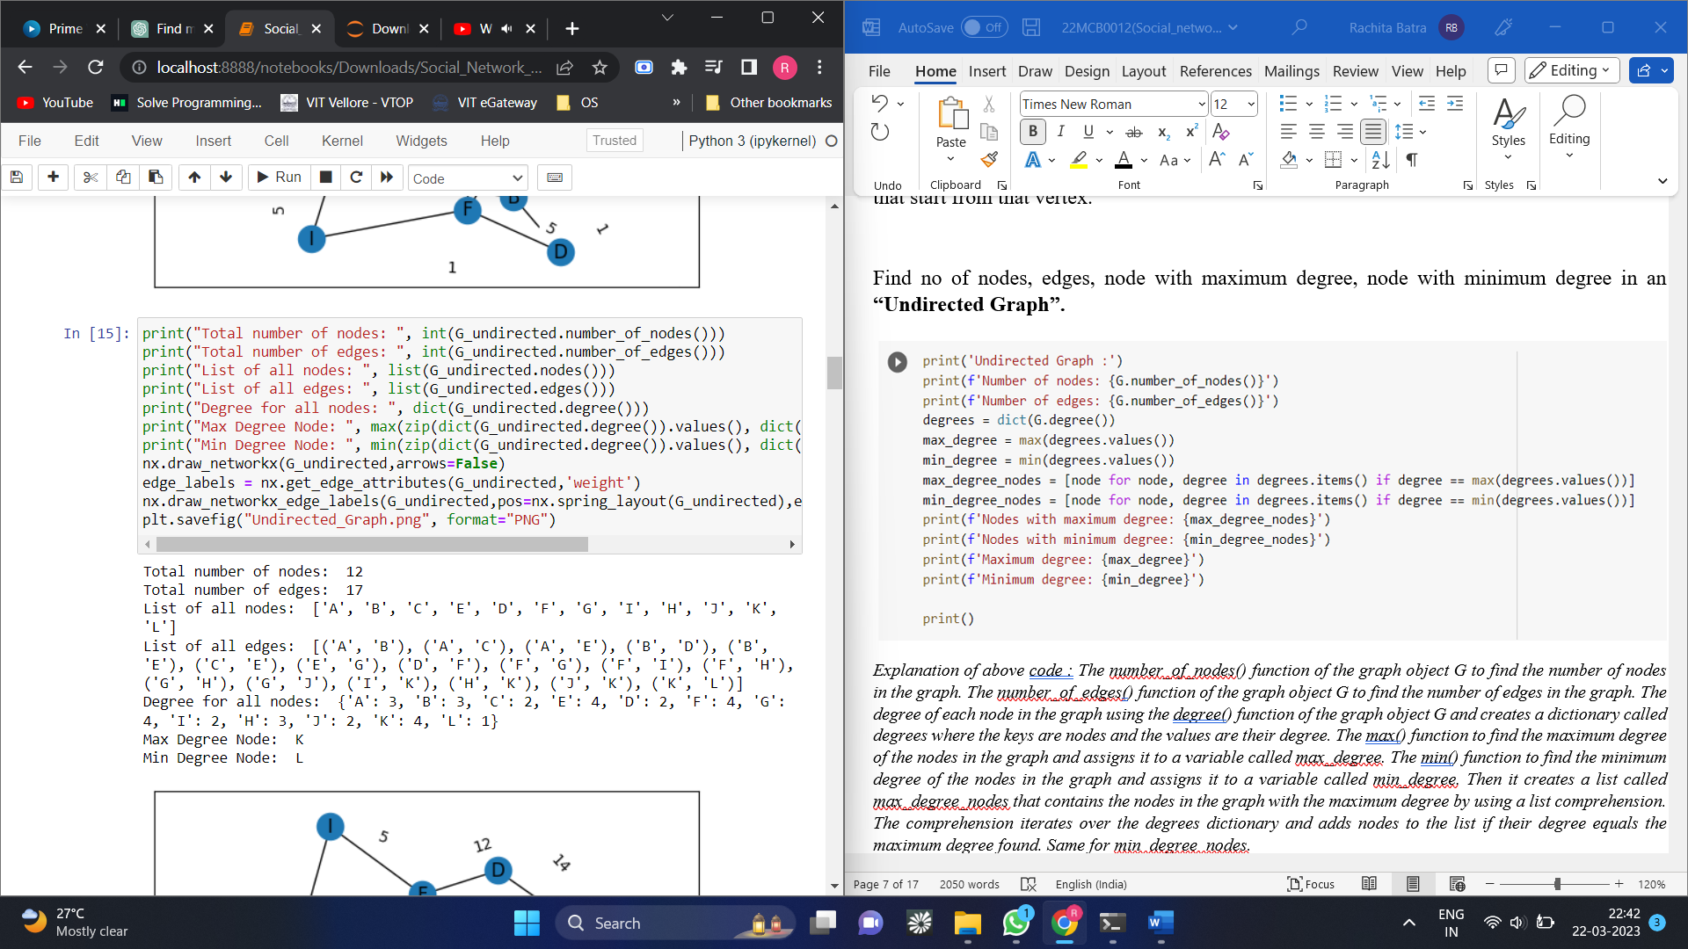

*Explanation of above code : The number_of_nodes() function of the graph object G to find the number of nodes in the graph. The number_of_edges() function of the graph object G to find the number of edges in the graph. The degree of each node in the graph using the degree() function of the graph object G and creates a dictionary called degrees where the keys are nodes and the values are their degree. The max() function to find the maximum degree of the nodes in the graph and assigns it to a variable called max_degree. The min() function to find the minimum degree of the nodes in the graph and assigns it to a variable called min_degree. Then it creates a list called max_degree_nodes that contains the nodes in the graph with the maximum degree by using a list comprehension. The comprehension iterates over the degrees dictionary and adds nodes to the list if their degree equals the maximum degree found. Same for min_degree_nodes.*

Find no of nodes, edges, node with maximum indegree, node with minimum indegree, node with maximum outdegree, node with minimum outdegree in an **“Directed Graph”.**

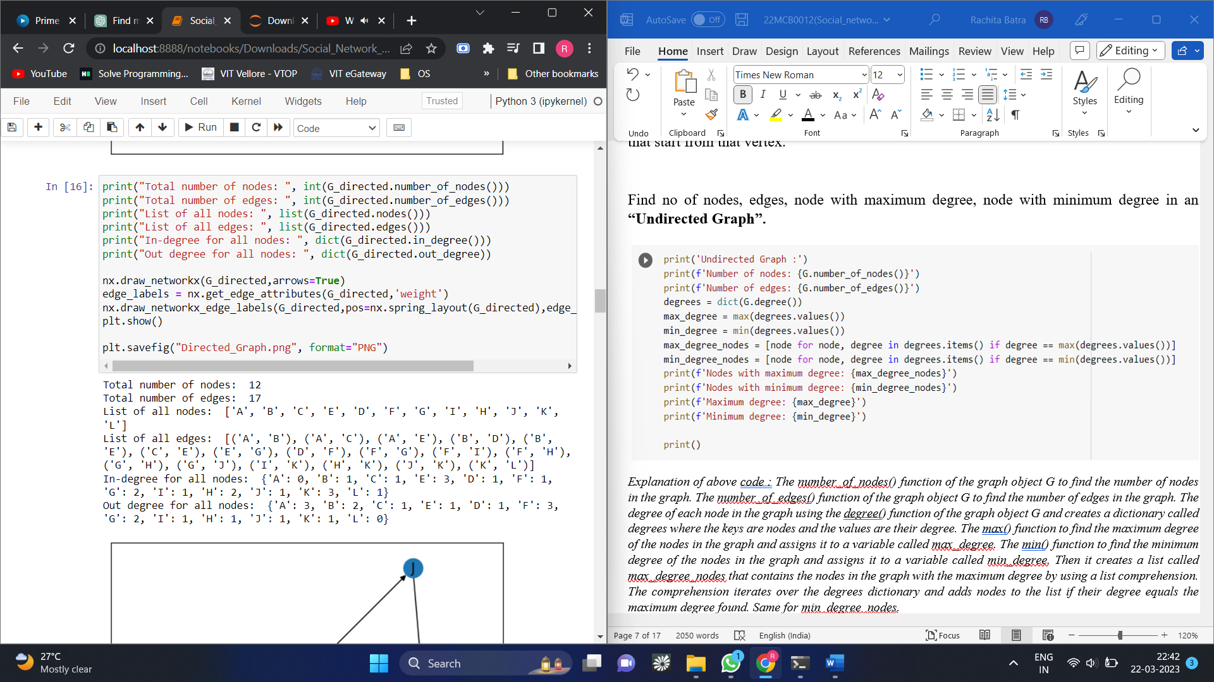

*Explanation of above code : To calculate the out-degree of each node in the graph using the out_degree() function of the graph object G and creates a dictionary called out_degrees where the keys are nodes and the values are their out-degree. The max() function used to find the maximum out-degree of the nodes in the graph and assigns it to a variable called max_out_degree. The min() function used to find the minimum out-degree of the nodes in the graph and assigns it to a variable called min_out_degree. Then it creates a list called max_out_degree_nodes that contains the nodes in the graph with the maximum out-degree by using a list comprehension. The comprehension iterates over the out_degrees dictionary and adds nodes to the list if their out-degree equals the maximum out-degree. Then it creates a list called min_out_degree_nodes that contains the nodes in the graph with the minimum out-degree by using a similar list comprehension. The comprehension iterates over the out_degrees dictionary and adds nodes to the list if their out-degree equals the minimum out-degree. Same for indegree.*

*PART-C*

**Adjacency Matrix:** An adjacency matrix is a matrix representation of a graph. It is a square matrix, where the rows and columns represent the nodes in the graph, and the elements of the matrix represent the edges between the nodes. If there is an edge between two nodes i and j, then the corresponding element in the matrix is 1, otherwise it is 0.

* **Adjacency Matrix for Un-directed Graph with weight**

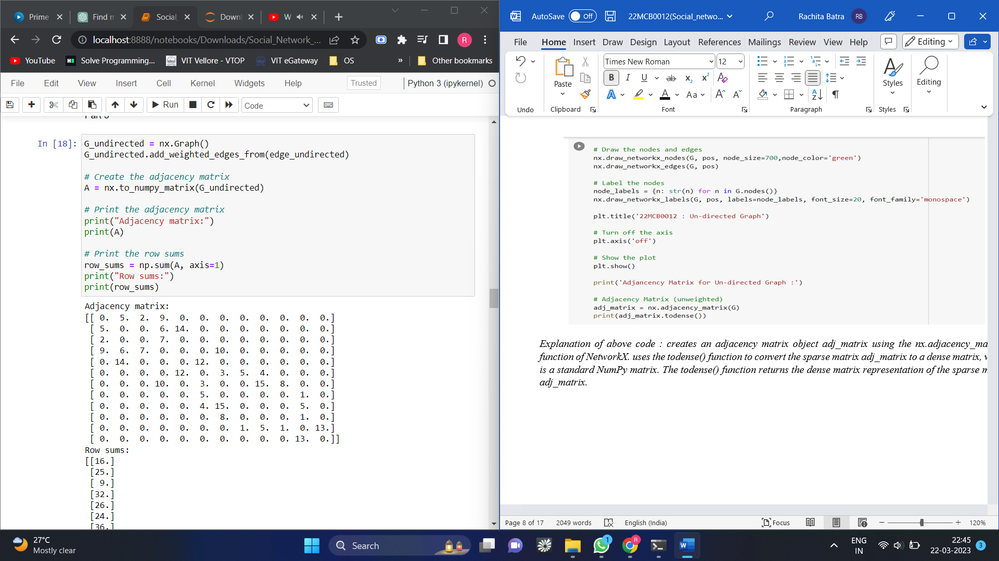

*Explanation of above code : creates an adjacency matrix object adj_matrix using the nx.adjacency_matrix() function of NetworkX. uses the todense() function to convert the sparse matrix adj_matrix to a dense matrix, which is a standard NumPy matrix. The todense() function returns the dense matrix representation of the sparse matrix adj_matrix.*

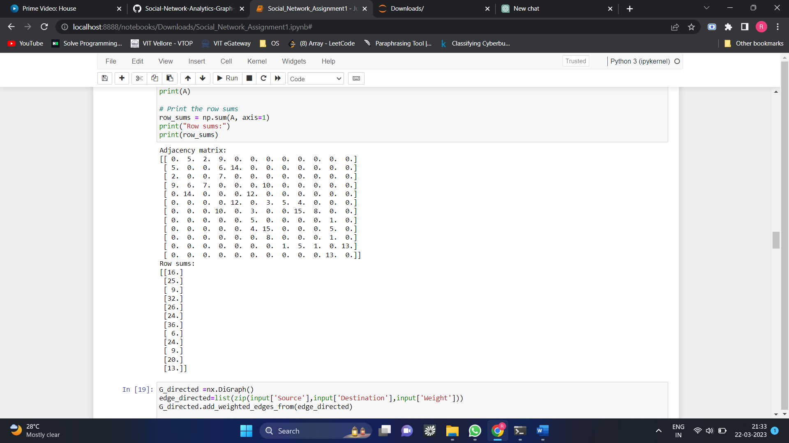

* **Adjacency Matrix for Directed Graph with weights**

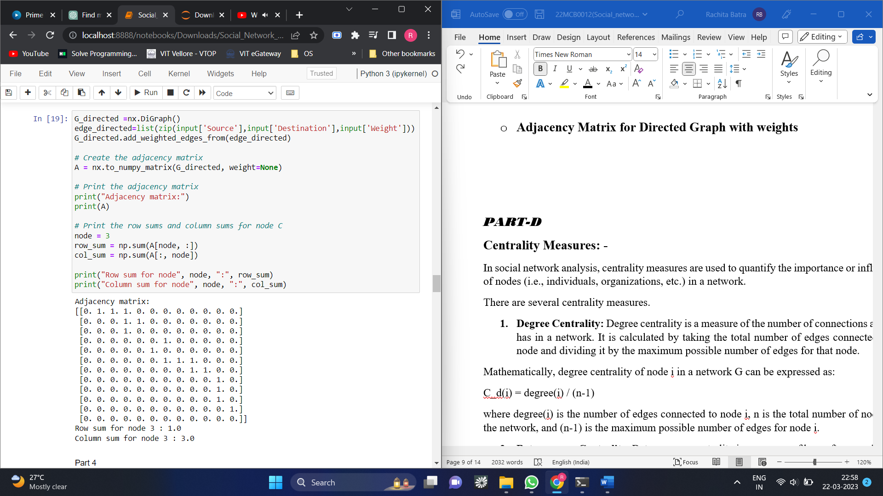

*PART-D*

**Centrality Measures: -**

In social network analysis, centrality measures are used to quantify the importance or influence of nodes (i.e., individuals, organizations, etc.) in a network.

There are several centrality measures.

1. **Degree Centrality:** Degree centrality is a measure of the number of connections a node has in a network. It is calculated by taking the total number of edges connected to a node and dividing it by the maximum possible number of edges for that node.

Mathematically, degree centrality of node i in a network G can be expressed as:

C_d(i) = degree(i) / (n-1)

where degree(i) is the number of edges connected to node i, n is the total number of nodes in the network, and (n-1) is the maximum possible number of edges for node i.

1. **Betweenness Centrality**: Betweenness centrality is a measure of how often a node acts as a bridge or intermediary between other nodes in the network. It is calculated by finding the shortest path between every pair of nodes in the network and then determining the proportion of those paths that pass through a given node.

Mathematically, betweenness centrality of node i in a network G can be expressed as:

C_b(i) = Σ(j,k) σ(j,k|i) / σ(j,k)

where σ(j,k) is the total number of shortest paths between nodes j and k, and σ(j,k|i) is the number of those paths that pass through node i.

1. **Eigenvector Centrality:** Eigenvector centrality is a measure of the influence of a node in a network based on the centrality of its neighbors. It is calculated using the eigenvectors of the adjacency matrix of the network.

Mathematically, eigenvector centrality of node i in a network G can be expressed as:

C_e(i) = (1/λ) Σ(j∈N(i)) A_ij C_e(j)

where λ is the largest eigenvalue of the adjacency matrix of the network, N(i) is the set of neighbors of node i, A_ij is the element of the adjacency matrix indicating whether nodes i and j are connected, and C_e(j) is the eigenvector centrality of node j.

**4. Closeness Centrality**: Closeness centrality is a measure of how easily a node can access other nodes in a network. It is calculated by finding the shortest path between a node and all other nodes in the network, and then summing up the lengths of those paths. The reciprocal of this sum is the closeness centrality.

Mathematically, closeness centrality of node i in a network G can be expressed as:

C_c(i) = 1 / Σ(j) d(i,j)

where d(i,j) is the length of the shortest path between nodes i and j.

**5. PageRank Centrality:** PageRank centrality is a measure of the importance of a node in a network based on the concept of random walks. It is calculated by considering a random surfer moving through the network, who follows links from one node to another with a probability determined by the weight of the links. Nodes with more incoming links and/or links from more important nodes are assigned a higher PageRank score.

Mathematically, PageRank centrality of node i in a network G can be expressed as:

C_p(i) = (1-d) / N + d Σ(j∈B_i) A_ji C_p(j) / d_j

where N is the total number of nodes in the network, d is a damping factor that determines the probability of the surfer following a link, B_i is the set of nodes that link to node i, A_ji is the element of the adjacency matrix indicating whether nodes j and i are connected, C_p(j) is the PageRank centrality of node j, and d_j is the out-degree of node j.

* **Calculating the centrality measures for directed graph**

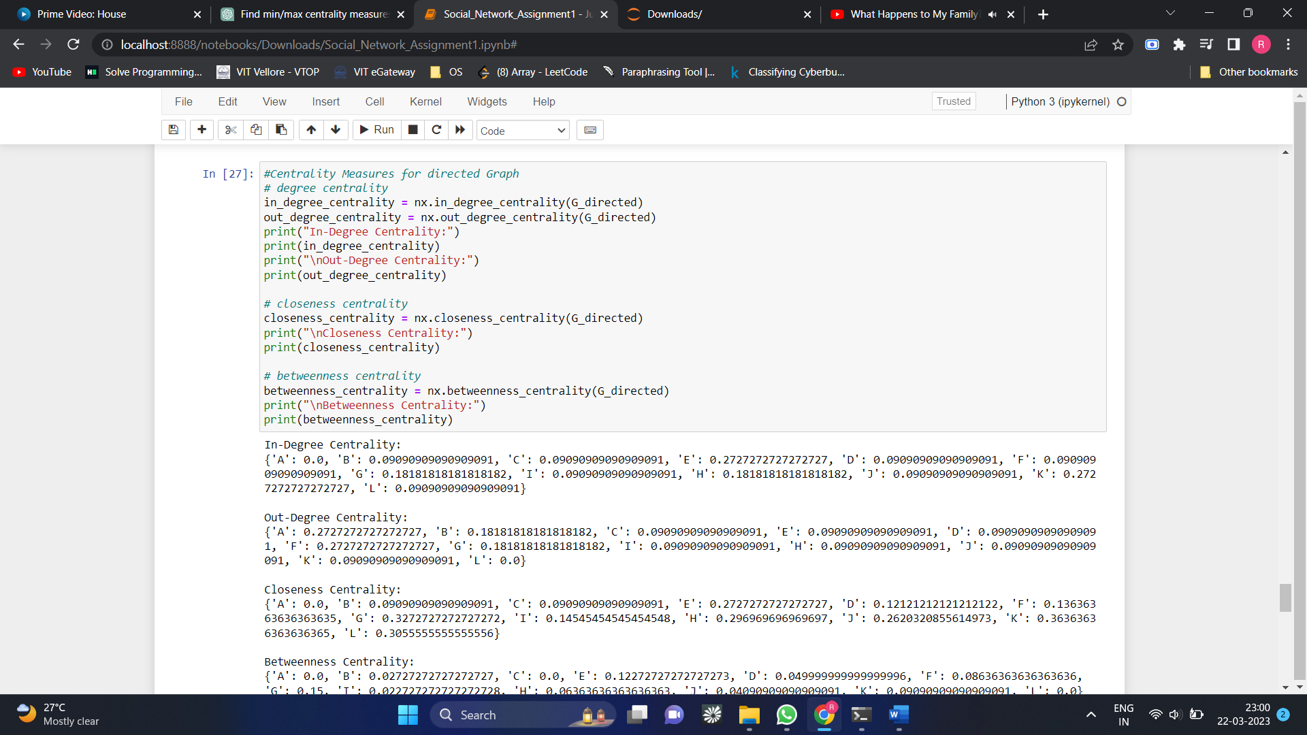

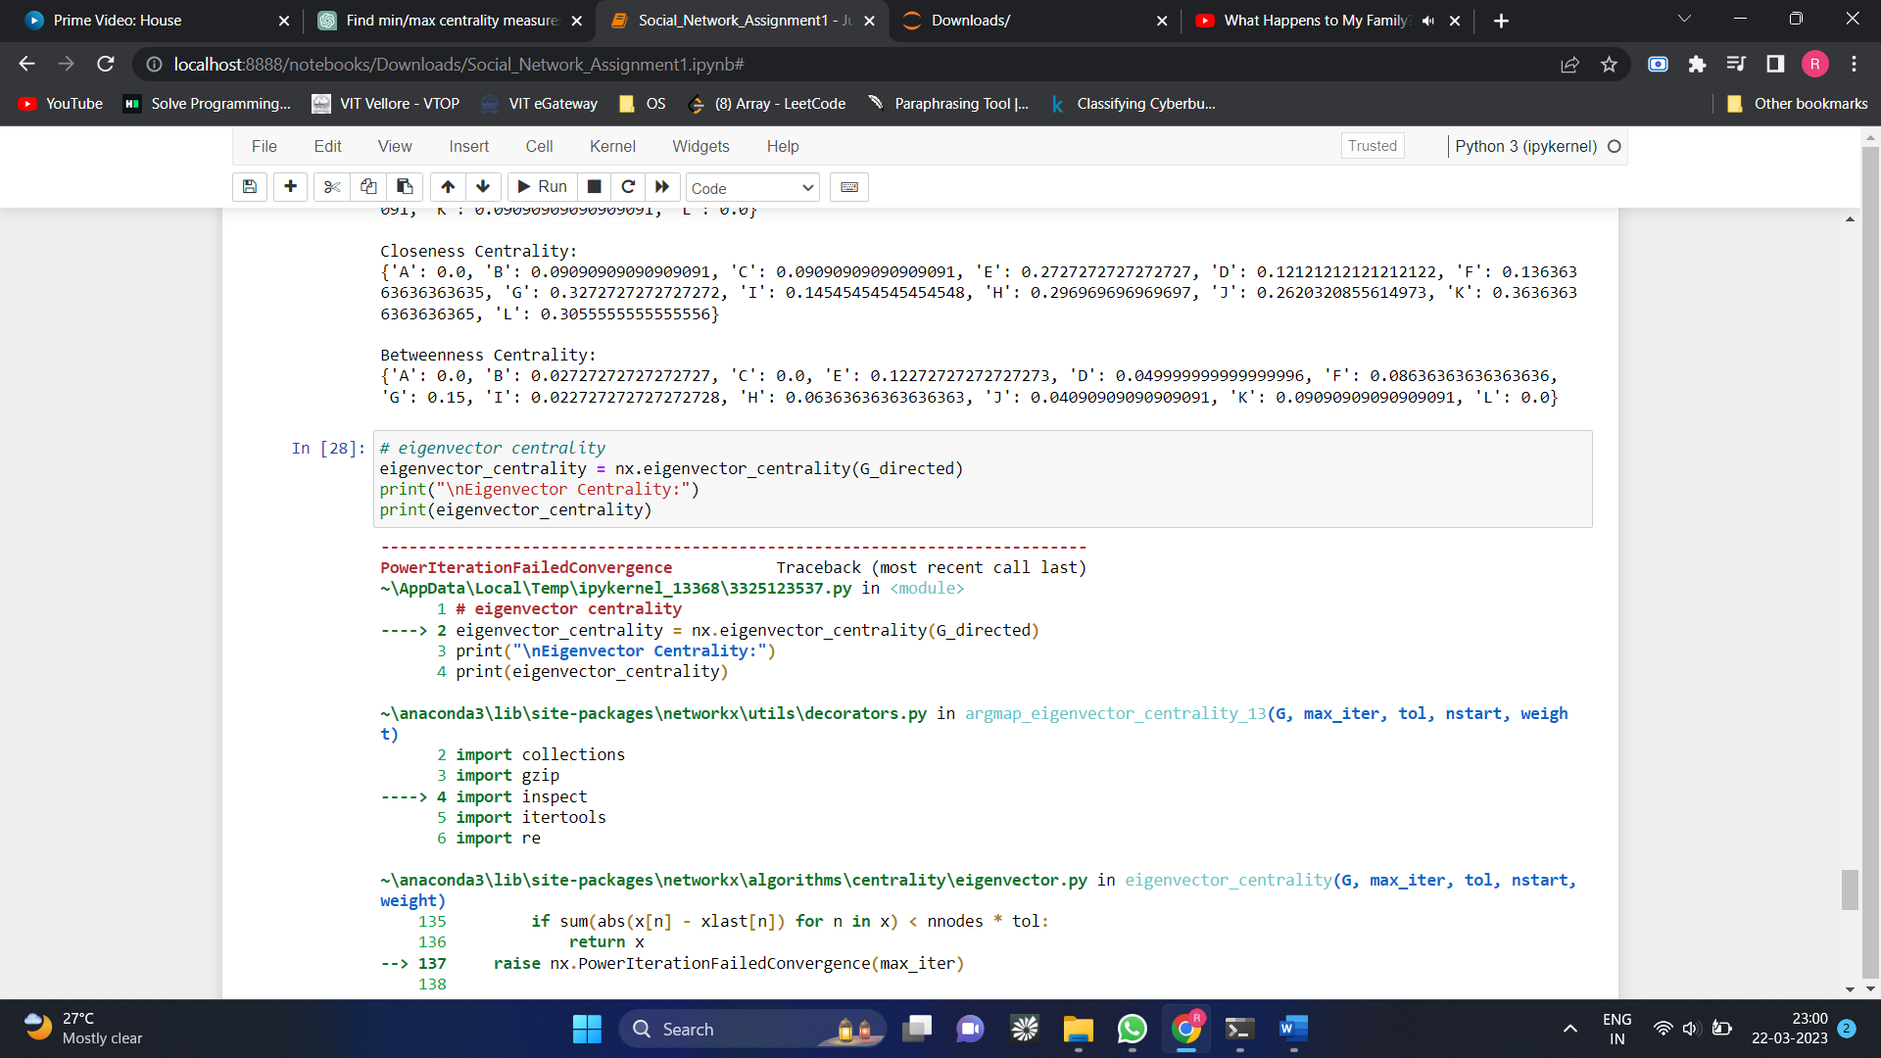 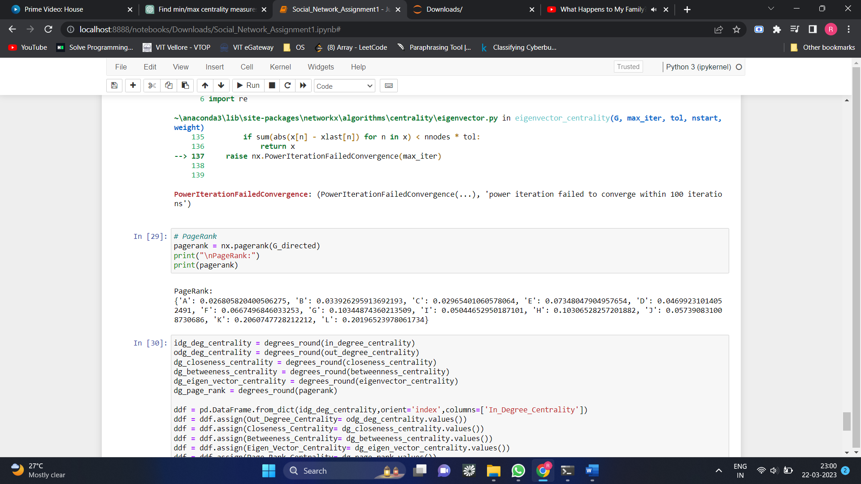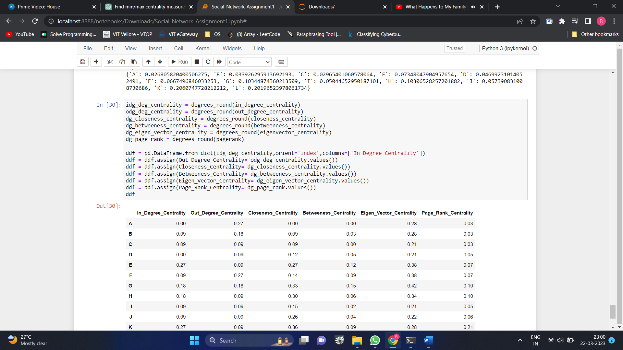

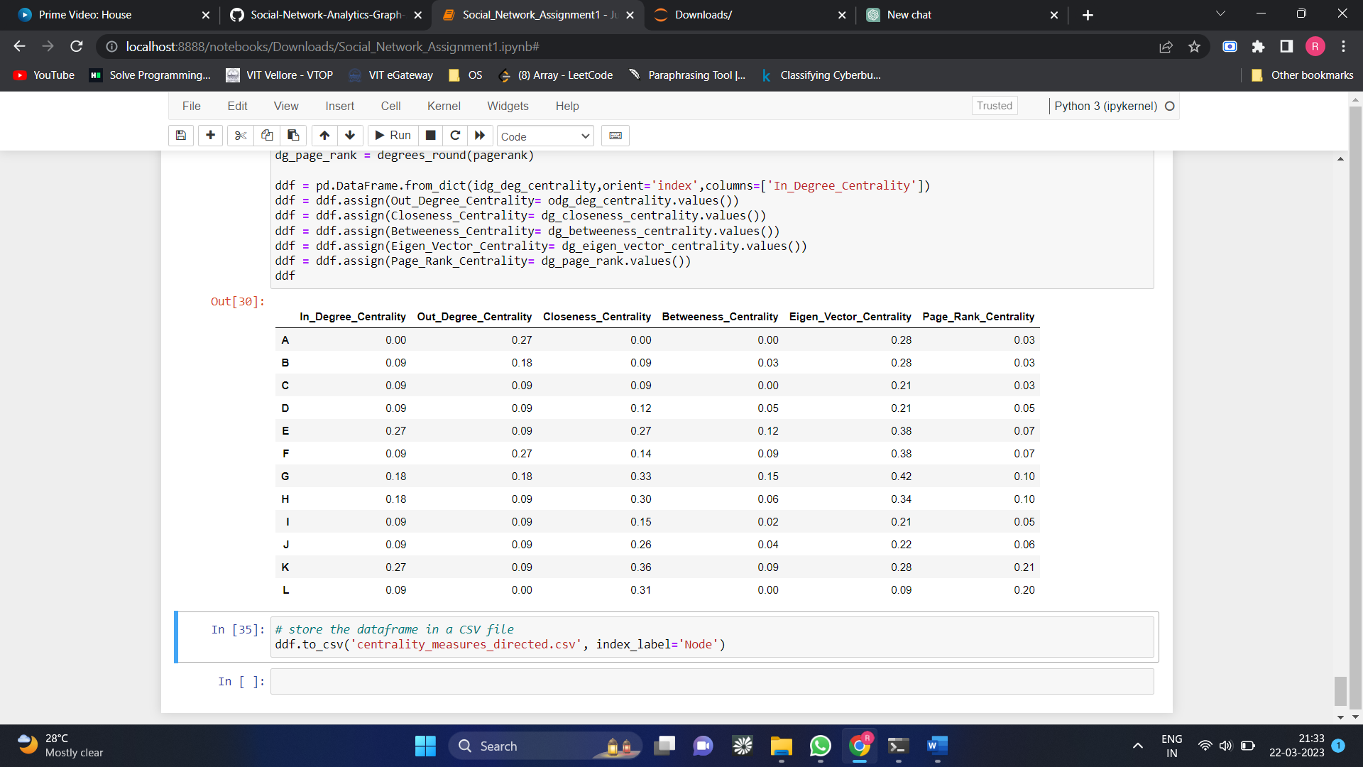

* **Analysing node with highest centrality for all centrality measures**

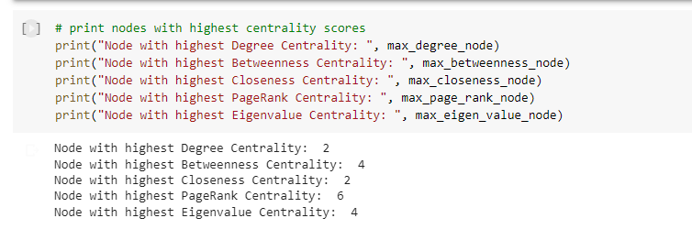

* **Analysing node with highest centrality score for all centrality measures**

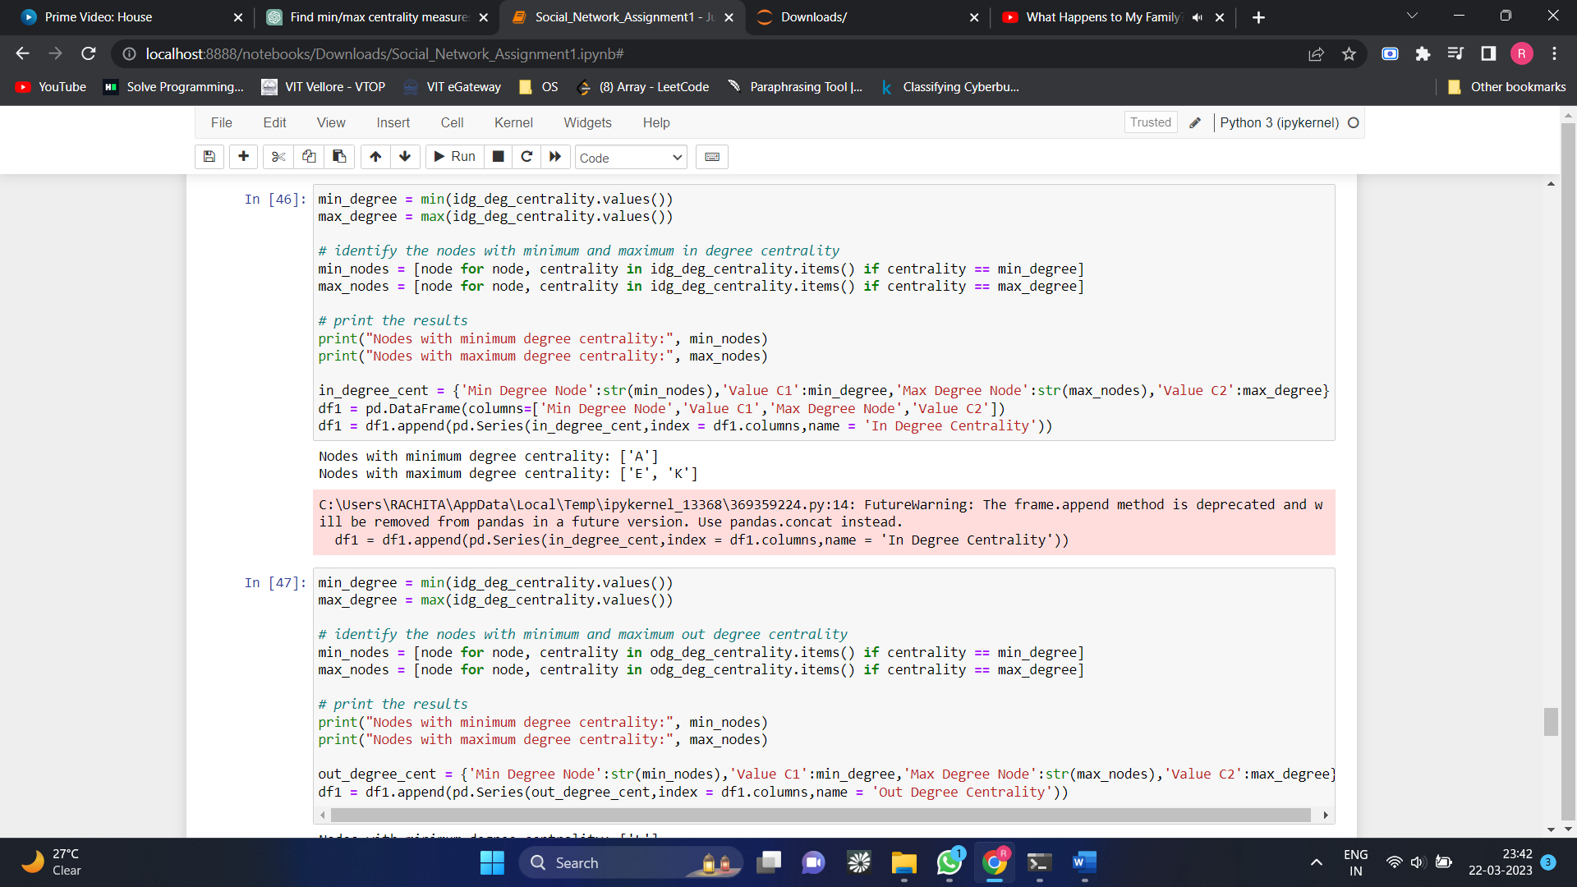

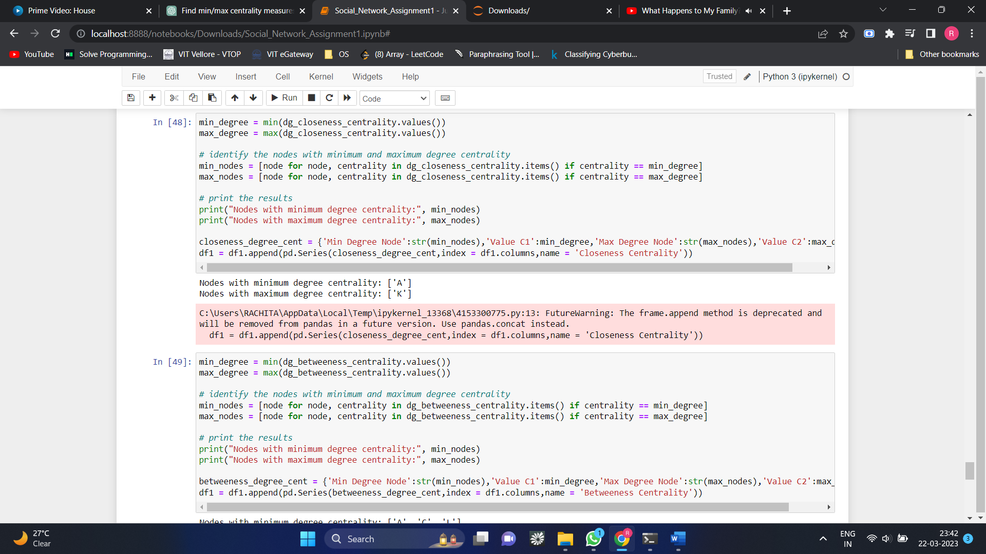

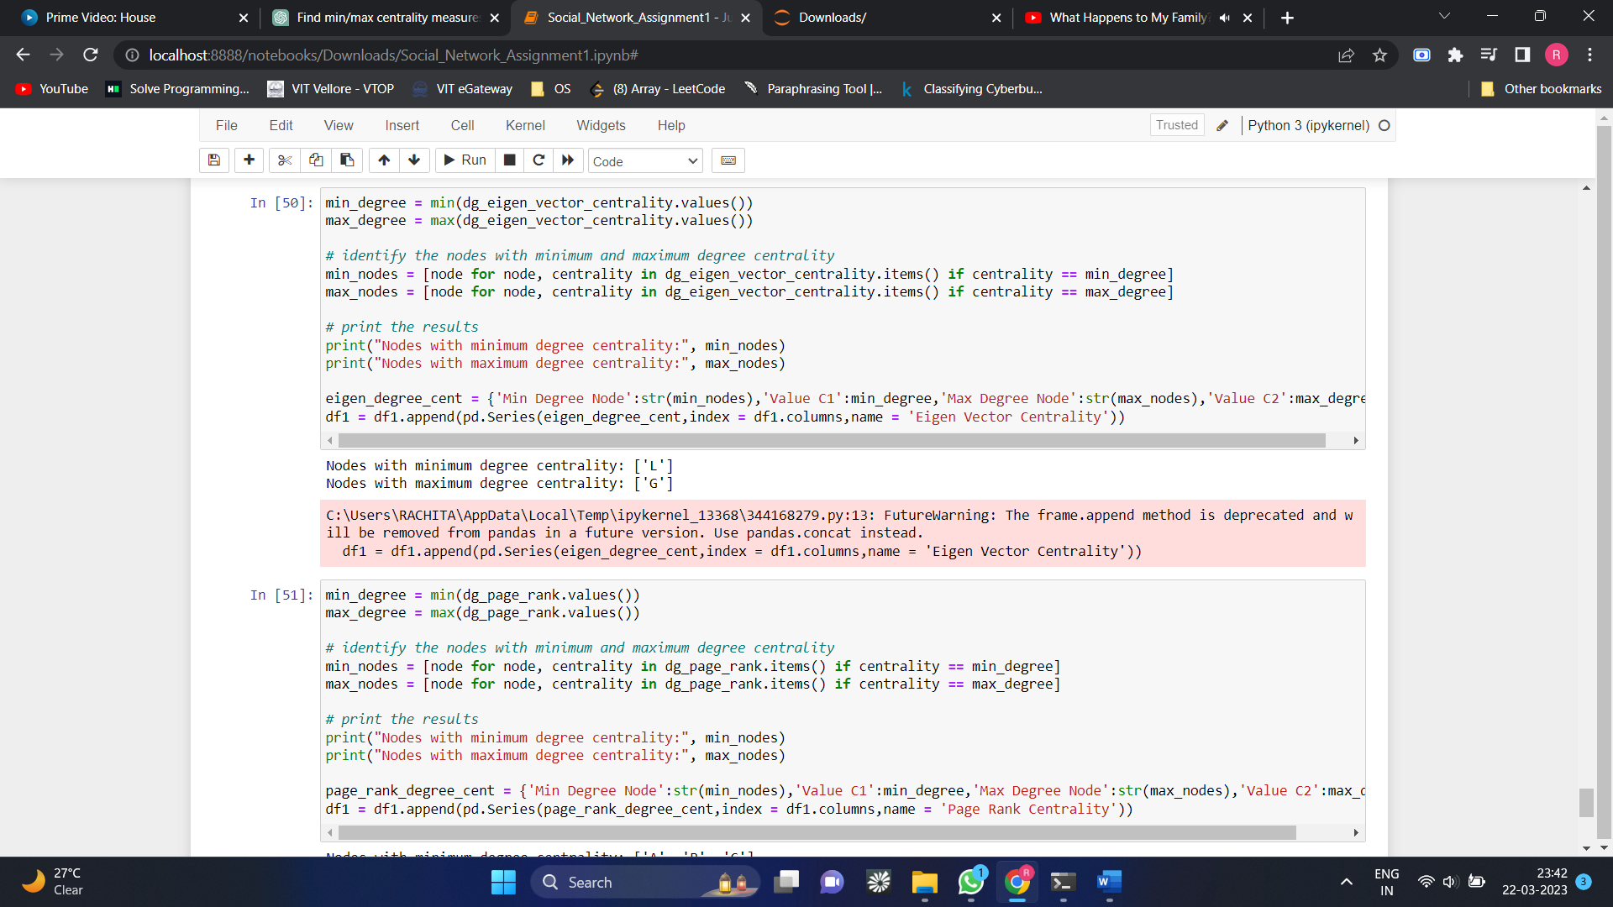

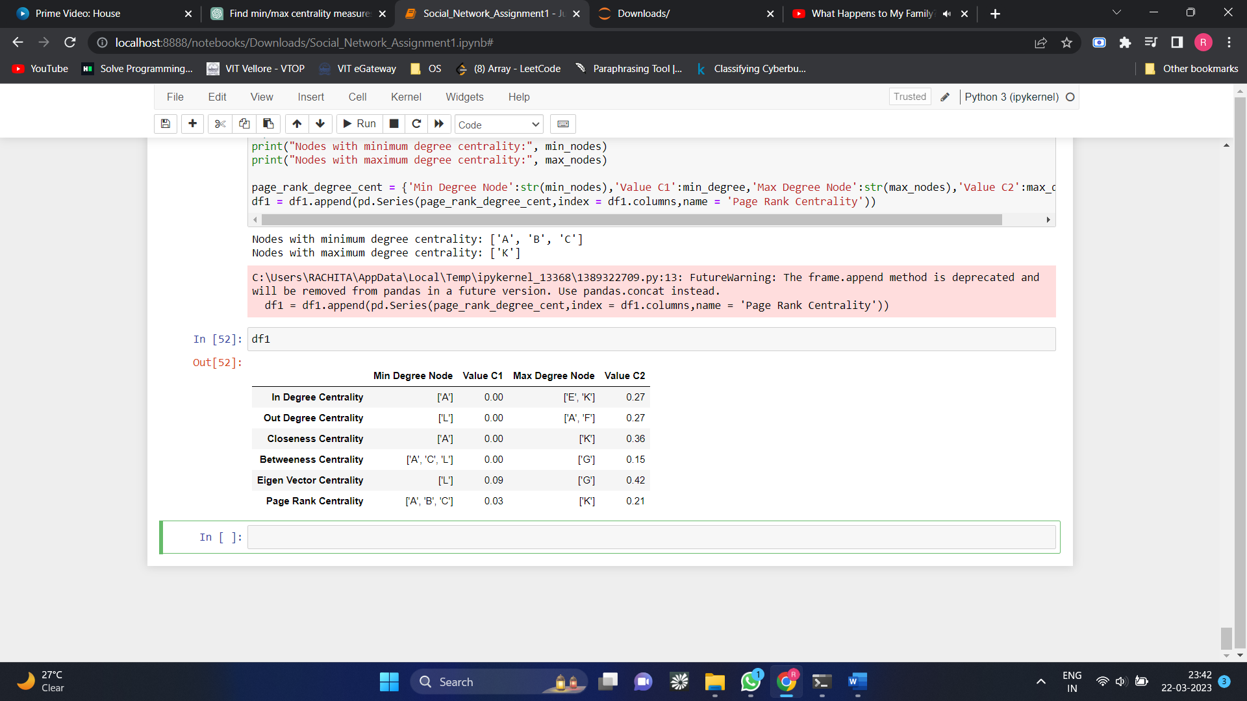

* **Calculating the centrality measures for Un- directed graph**

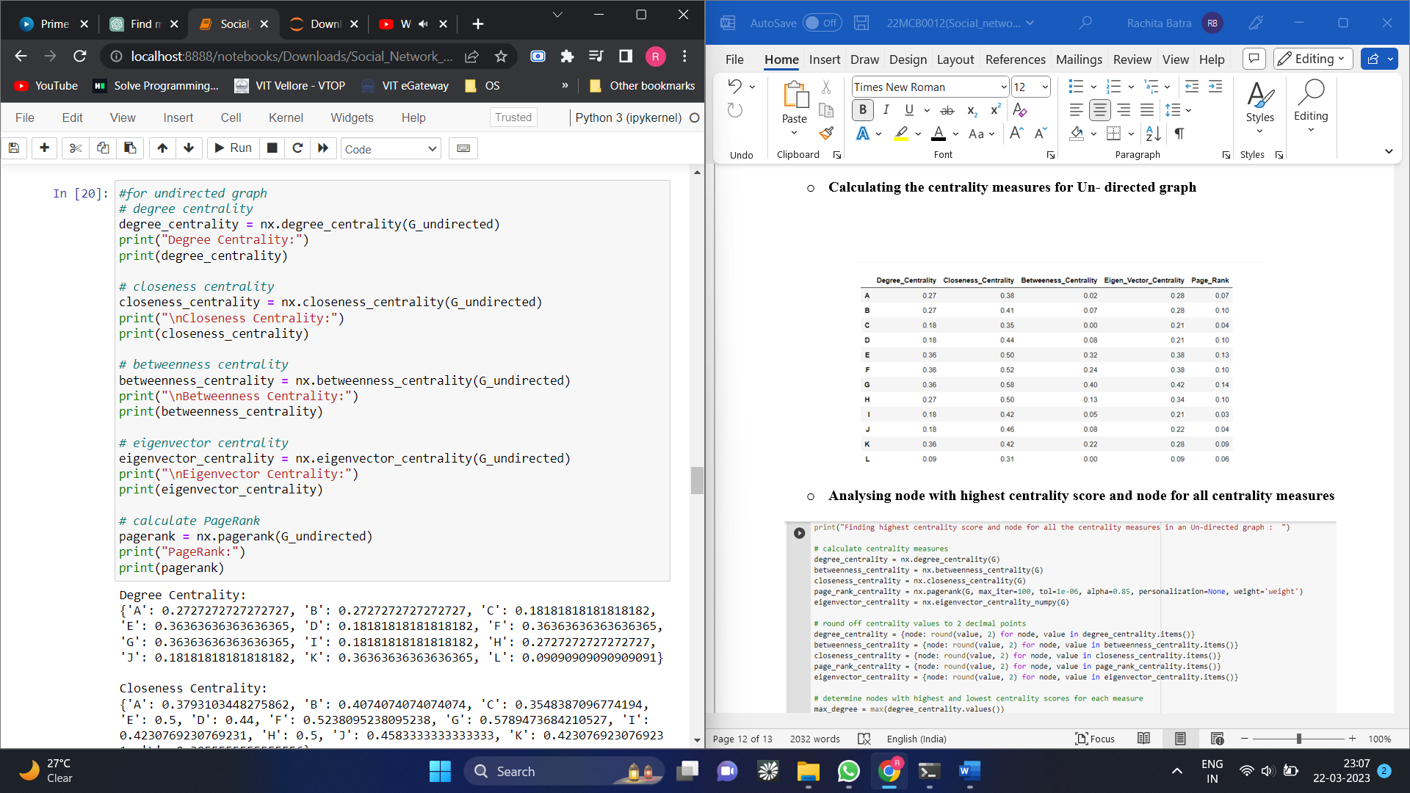

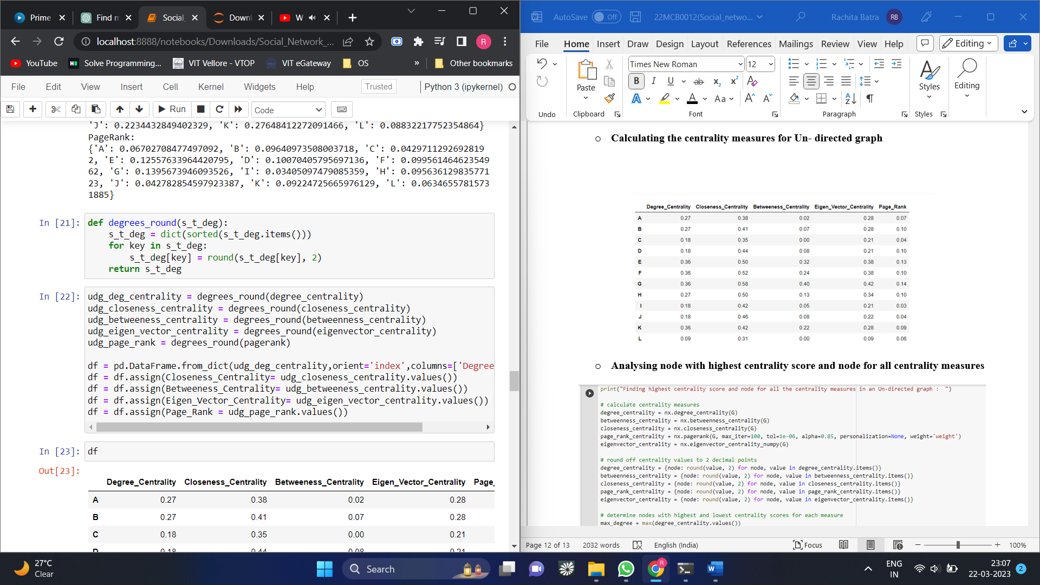

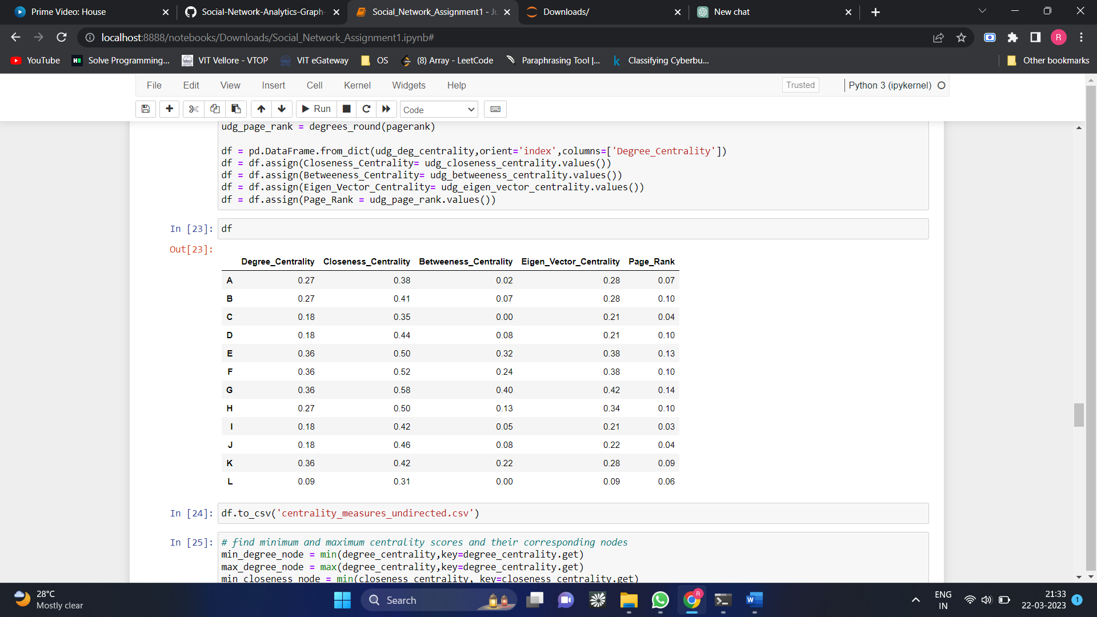

* **Analysing node with highest centrality score and node for all centrality measures**

